**5 (a) Pulse Amplitude Modulation (PAM) & Demodulation**

**5a.1 Objective**

Study of Pulse Amplitude Modulation & Demodulation with Sample, Sample & Hold & Flat Top Circuit .

**5a.2 Equipment required**

Scientech 2110 with Power Supply cord

Scientech Oscilloscope with connecting probe

Connecting cords

**5a.3 Wiring Diagram**

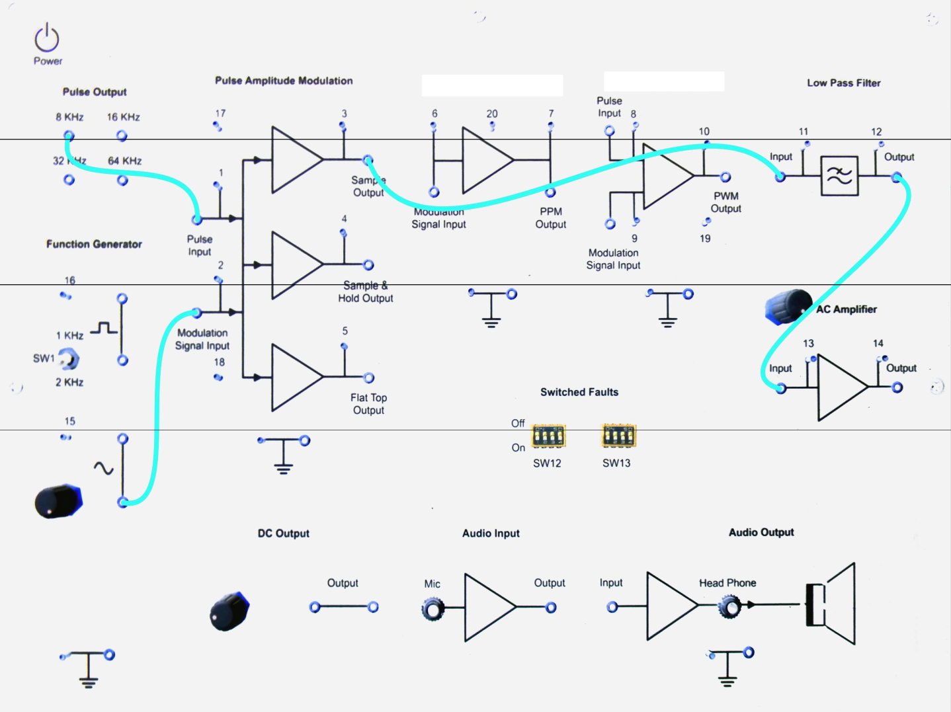

**Figure 5a.1 Pulse Amplitude Modulation and Demodulation**

**5a.4 Procedure**

1. Connect the circuit as shown in Figure 5a.1

2. Output of sine wave to modulation signal input in PAM block keeping the switch in 1 KHz position.

3. 8 KHz pulse output to pulse input

4. Output of low pass filter to input of AC Amplifier. Keep the gain pot in AC Amplifier block in anti clock wise position.

5. Switch ‘On’ the Power Supply & Oscilloscope.

6. Observe the outputs at TP (3) together with Modulation signal input TP (3) and Pulse input TP (1). This is a Natural sampling output.

7. Connect the Sample output to the input of low pass filter. Observe the output of the Low pass filter TP (12) together with Modulation signal input TP (2).

8. Observe the output of the AC Amplifier TP (14) together with Modulation signal input TP (2). Vary the Gain of AC Amplifier to get the unclipped output. Vary the amplitude of input; the amplitude of output will vary.

9. Observe the Flat Top output at TP (5), together with Modulation signal input TP (2) and Pulse input TP (1).  This is Flat Top Sampling output.

10. Connect the Flat top output to the input of low pass filter Observe the output of the Low pass filter TP (12) together with Modulation signal input TP (2).

11. Observe the output of the AC Amplifier TP (14) together with Modulation signal input TP (2).  Vary the Gain of AC Amplifier to get the unclipped output. Vary the amplitude of input; the amplitude of output will vary.

12. Observe the output of Sample & Hold circuit at TP4, together with Modulation signal input TP (2) and Pulse input TP (1).  This is Sample & Hold output.

13. Connect the Sample & Hold output to the input of low pass filter. Observe the output of the Low pass filter TP (12) together with Modulation signal input TP (2).

14. Observe the output of the AC Amplifier TP (14) together with Modulation signal input TP (2). Vary the Gain of AC Amplifier to get the unclipped output. Vary the amplitude of input; the amplitude of output will vary.

15. Vary the amplitude potentiometer and frequency change over switch & observe the effect on these three outputs.

16. Vary the frequency of pulse, by connecting the pulse input to the 4 frequencies available i.e. 8, 16, 32, 64 kHz in Pulse output block.

**5a.5 Model Graph**

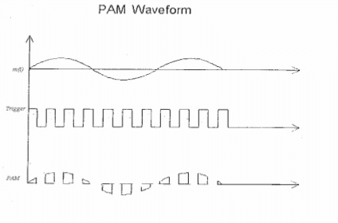

Fig. 5a.2 PAM Modulated Waveform

**Natural Sampling Output**

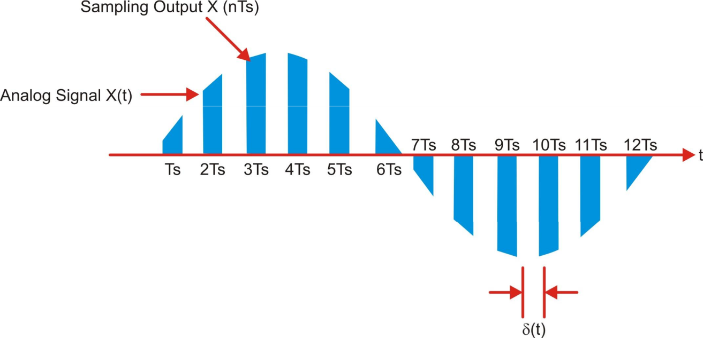

**Flat top sampling Output**

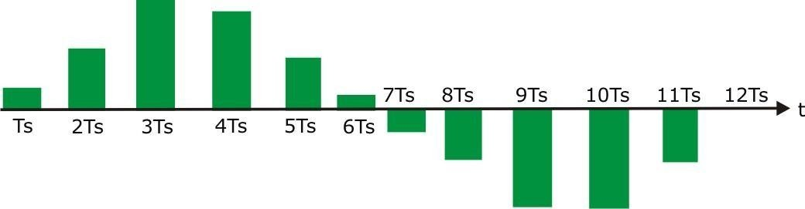

**5a.6 Tabulation**

|  |  |  |
| --- | --- | --- |
| **Signal** | **Amplitude (V)** | **Time Period (ms)** |
| **Sinusoidal waveform** |  |  |
| **Pulse Carrier waveform** |  |  |
| **Sample Output** |  |  |
| **Sample and Hold Output** |  |  |
| **Flat Top Output** |  |  |
| **Demodulated waveform** |  |  |

**5a.7 Lab Result**

Thus the PAM and its demodulation were performed and graphs were plotted.

**(B) PULSE POSITION MODULATION AND DEMODULATION**

**5b.1 Objective**

To analyze a PPM system and interpret the modulated and demodulated waveforms .

**5b.2 Hardware Required**

PPM Modulator and Demodulator Trainer Kit

Power supply Cord

Digital Oscilloscope

**5b.3 Introduction**

In Pulse Position Modulation both the pulse amplitude and pulse duration are held constant but the position of the pulse is varied in proportional to the sample values of the message signal .Pulse time modulation is a class of signaling techniques that encodes the sample values of the analog signal on to the time axis of a digital signal and it is analogous to angle modulation technique. The two types of PTM are PWM and PPM. In PPM the analog sample value determines the position of a narrow pulse relative to the clocking time. In PPM rise time of pulse decides the channel bandwidth it has low noise interference.

**5b.4 Procedure**

1. Connect the circuit as shown in Figure 5b 2.1
2. A modulating signal is given to the PPM modulator
3. The amplitude and the time duration of the modulating signal are observed using CRO.
4. PPM output is observed from the output of PPM modulator stage and the amplitude and time duration of the PPM wave are noted down.
5. For Demodulation process, PPM signal is applied to the filter circuit and then to amplifier as shown in Figure 5b2.2
6. After demodulation the original signal is recovered.

**5b.5 Wiring Diagram**

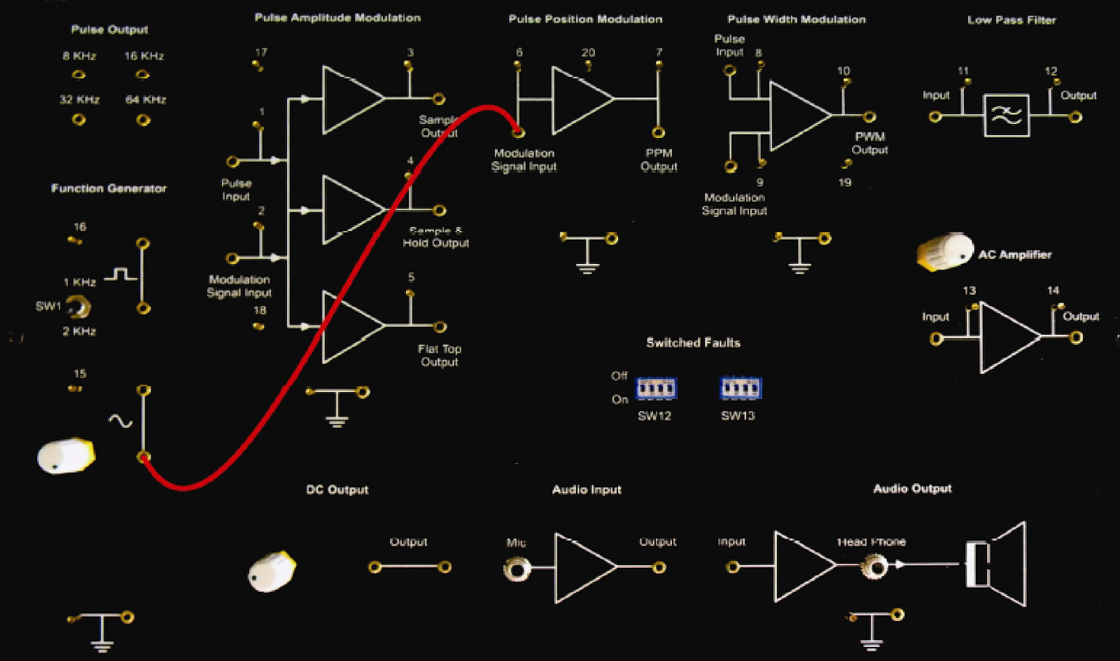

**Figure 5b.2.1 Wiring Diagram for Modulation**

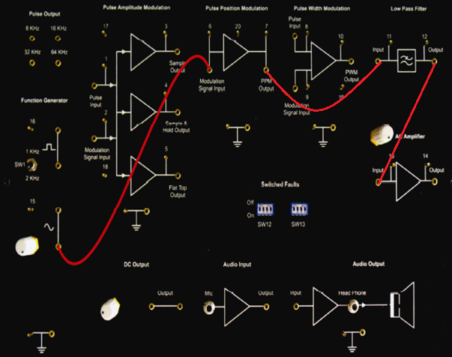

**Figure 5b.2.2 Wiring Diagram for Demodulation**

**5b.6 Model Graph:**

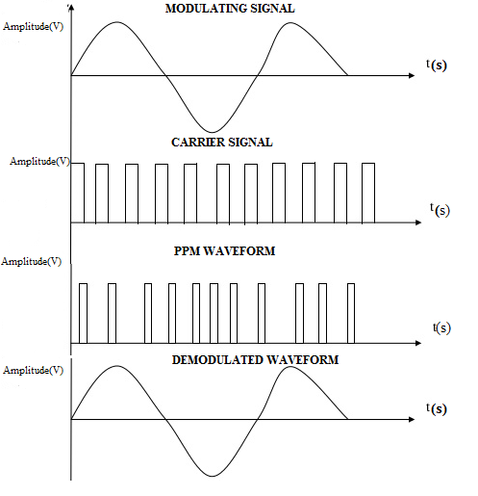

**5b.7 PPM Modulation**

|  |  |  |  |
| --- | --- | --- | --- |
| **Name of the Signal** | **Amplitude(V)** | **Time Period(ms)** | **Frequency(Hz)** |
| Message signal |  |  |  |
| Carrier Signal |  |  |  |
| Modulated Signal |  |  |  |

**PPM Demodulation**

|  |  |  |  |
| --- | --- | --- | --- |
| **Name of the Signal** | **Amplitude(V)** | **Time Period(ms)** | **Frequency(Hz)** |
| LPF Signal |  |  |  |
| Demodulated signal |  |  |  |

**5b.8 Lab Result**

Thus the Pulse Position modulation and demodulation were performed and graphs were plotted.

**5 (C) PULSE WIDTH MODULATIONS AND DEMODULATION**

**5c.1 Objective**

Study of PWM using different Sampling Frequency and its demodulation.

**5c.2 Equipment Required**

Scientech 2110 with Power Supply cord

Scientech Oscilloscope with connecting probe

Connecting cords

**5c.3 Wiring Diagram**

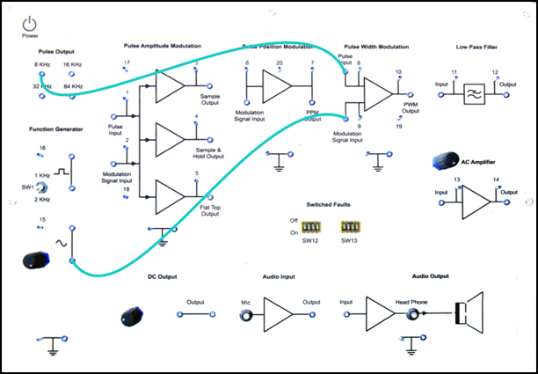

**Figure 5c.3.1 Wiring Diagram for PWM Modulation**

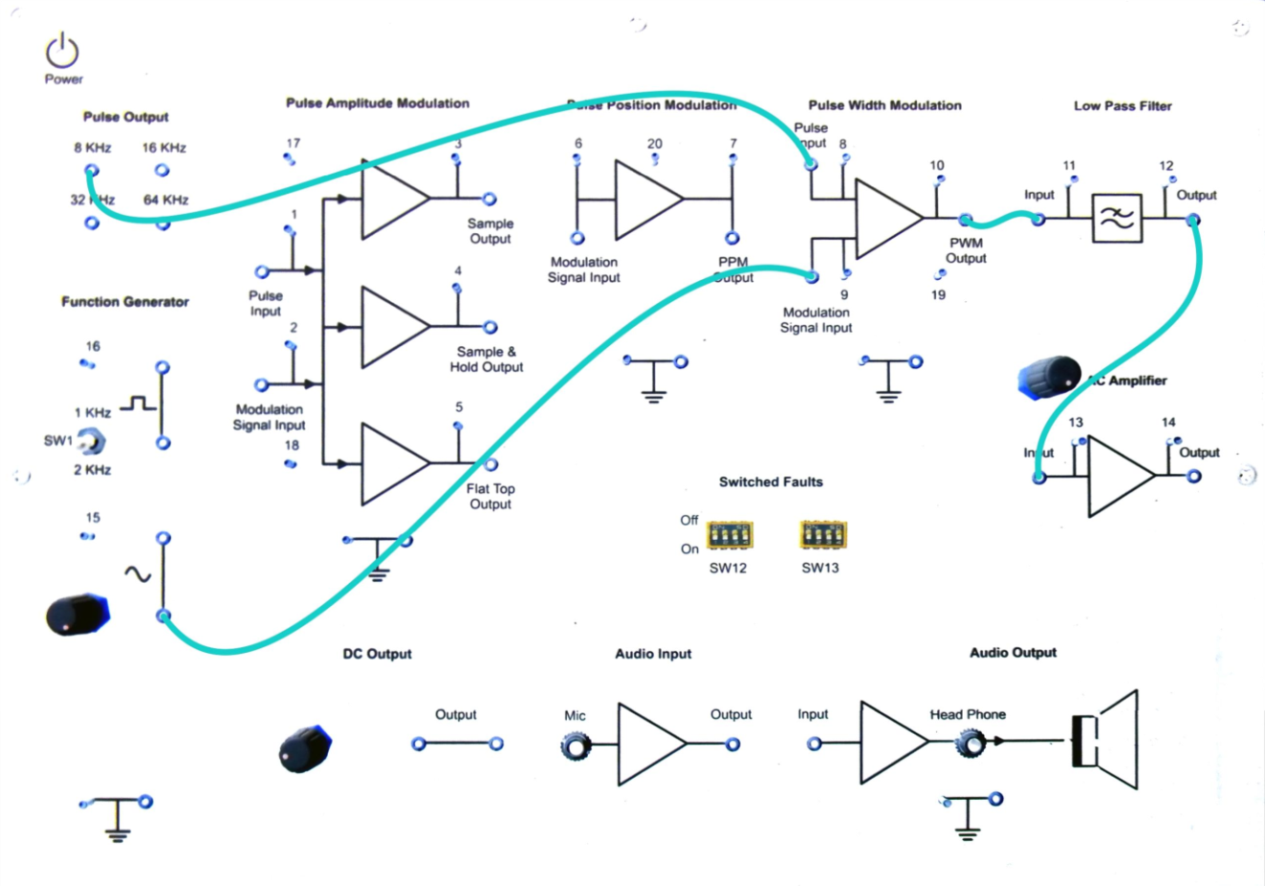

**Figure 5c.3.2 Wiring Diagram for PWM Demodulation**

**5c.4 Procedure**

1. Connect the circuit as shown in the Figure 5c 3.1
2. 1 KHz sine wave output of Function Generator block to modulation input of PWM block.
3. 8 KHz square wave output to pulse input of PWM block.
4. Switch ‘On’ the Power Supply & Oscilloscope.
5. Observe the PWM outputs at TP (10) together with Modulation signal input TP (9).
6. Vary the amplitude of sine wave and see its effect on width of pulse output.
7. Also,  change  the  frequency  of  the  pulse  by  connecting  the  pulse  input  to different pulse frequencies viz. 8 KHz, 16 KHz, 32 KHz and see the variations in the PWM output.
8. Switch ‘On’ fault No. 1, 2, & 5 one by one & observes their effect on PWM

    Output and tries to locate them.

9. Output of low pass filter to input of AC Amplifier.

10. Switch ‘On’ the Power Supply & Oscilloscope.

11. Observe the waveform at the output of Low pass filter TP12 together with modulation signal input (9).

12. Then observe the demodulated output at the output of AC Amplifier TP14 together with modulation signal input TP (9).  Vary the Gain of AC Amplifier to get the unclipped output. Vary the amplitude of input; the amplitude of output will vary.

13. Try varying the amplitude of sine wave signal; you will observe that the output signal varies similarly.

14. Switch ‘On’ fault no, 1, 2, 5 & 8 one by one at a time. Observe their effects on final output and try to locate them.

15. Switch ‘Off’ the Power Supply

**5c.5 Model Graph**

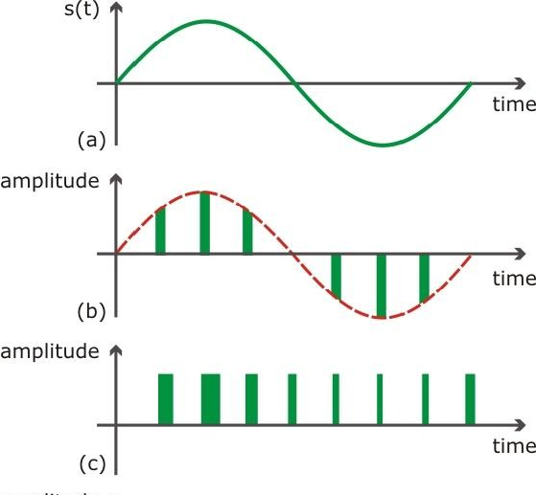  
  
**Figure 5c.3 (a) Input Waveform    (b) PAM Waveform (c) PWM Waveform**

**5c.6 Tabulation**

|  |  |  |
| --- | --- | --- |
| **Signal** | **Frequency** | **Amplitude** |
| **Sinusoidal waveform** |  |  |
| **Pulse waveform** |  |  |
| **Demodulated waveform** |  |  |

**5c.7 Pre Lab Questions**

1.State Sampling Theorem.

          2. Why Flat Top sampling more preferred than natural sampling?

## 3. What is Pulse width Modulation?

## 4. Compare different pulse modulation system.

5. What is Pulse Position Modulation?

**5c.8.Postlab Question**

1. A Signal of maximum frequency 10 KHz is sampled at Nyquist rate.Find the time interval between the successive samples.
2. What is  the Nyquist rate for the signal x(t)=2cos(2000πt)cos(7000πt)?
3. Which of the pulse modulation system would be affected if the synchronization between transmitter and receiver fails?
4. Determine the SyQuest rate and Nyquist interval corresponding to signal given by,

x(t) =1+sin(3000πt)+cos(5000πt)

5. A band limited with a maximum frequency of 5 KHz is sampled is to be sampled. According to the sampling theorem find the sampling frequency.

**5c.9 Lab Result**

Thus the PWM and its demodulation were performed and the graphs were plotted.